**Assignment – 3**

|  |  |
| --- | --- |
| Student Name/ID Number: | Agung Yuda Pratama/BDSE-0922-076 |
| Unit Number and Title: | Develop Project Design |
| Academic Year: | 2022 |
| Unit Assessor: | Arvinder Kaur |
| Project Title: | Project Proof Of Concept (POC) |
| Issue Date: |  |
| Submission Date: |  |
| Internal Verifier Name: |  |
| Date: | July 2023 |

|  |
| --- |
| **Learner declaration** |
|  |
| I certify that the work submitted for this assignment is my own and that research sources are fully acknowledged.  Student signature: Date: July 2023 |

**MEALS ON WHEELS**

**Assignment 3 - Project Proof Of Concept (POC)**



**AGUNG YUDA PRATAMA (BDSE-0922-076)**

**SOFTWARE ENGINEERING**

**LITHAN EDUCLAAS**

**(2023)**

**Use Case Diagram**

Use-case diagrams describe a system's high-level functions and scope. The interactions between the system's actors are also depicted in these diagrams. Instead of explaining how the system works inside, use cases and actors in use-case diagrams show what the system does and how the actors interact.

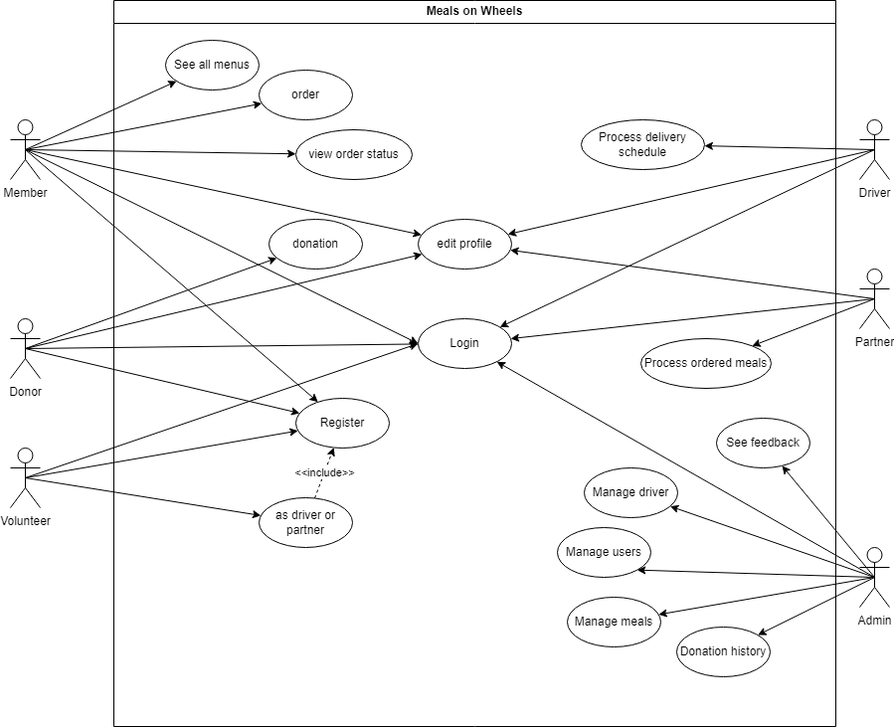

Meals on wheels

1. Login screen   
   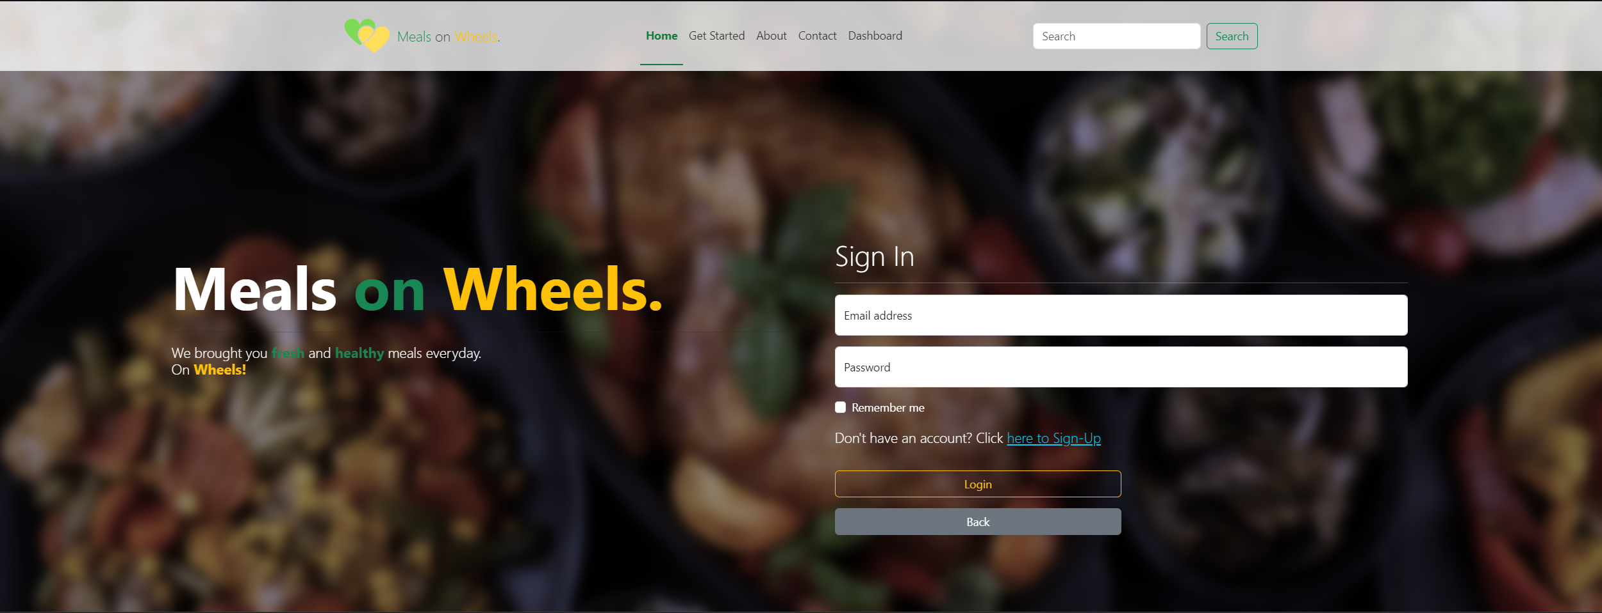
2. Register Screen  
   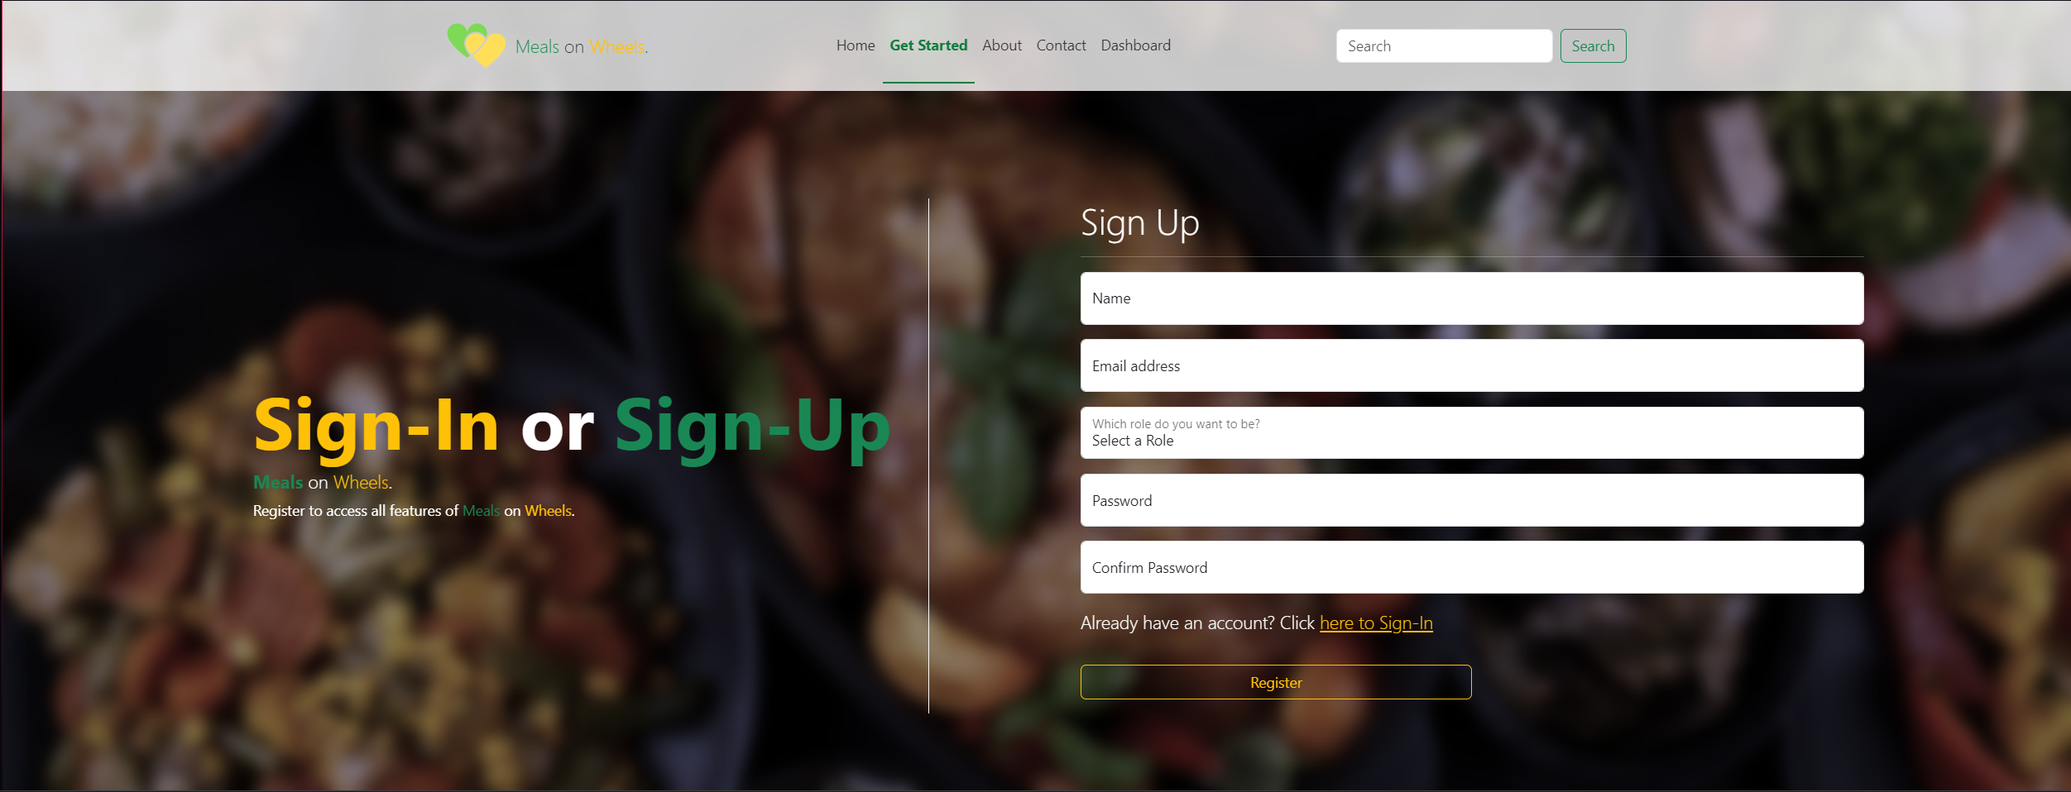
3. Landing Page   
   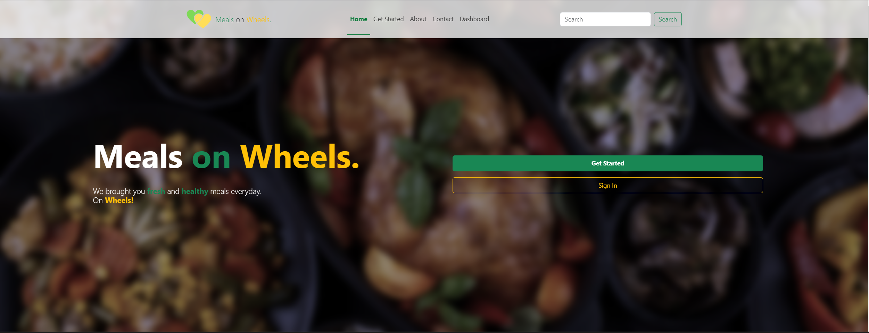  
   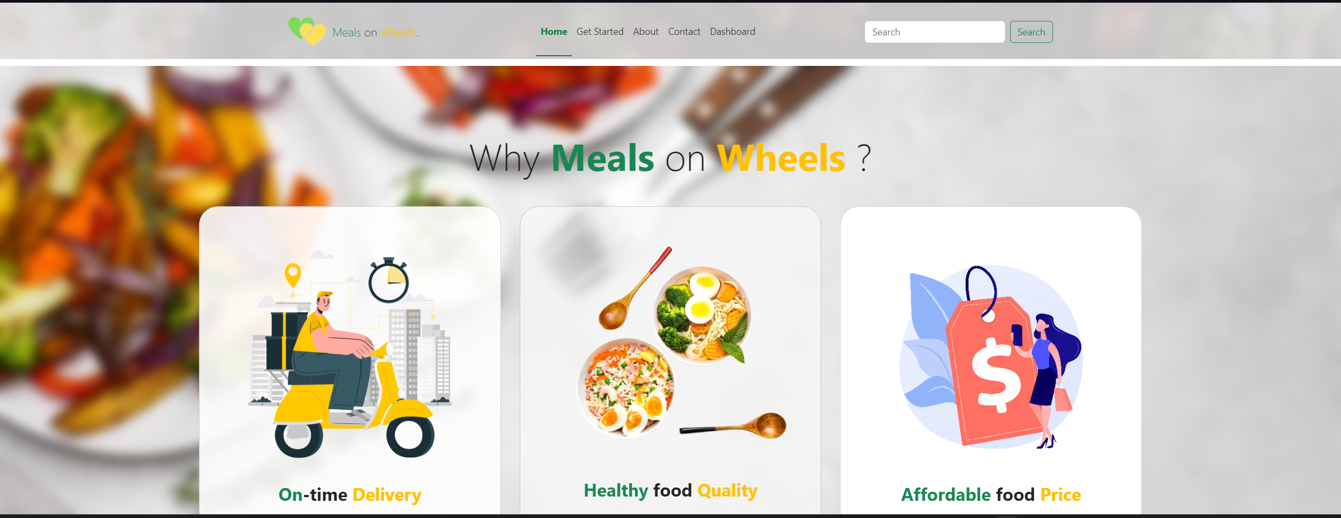  
   
4. About Us Page  
     
   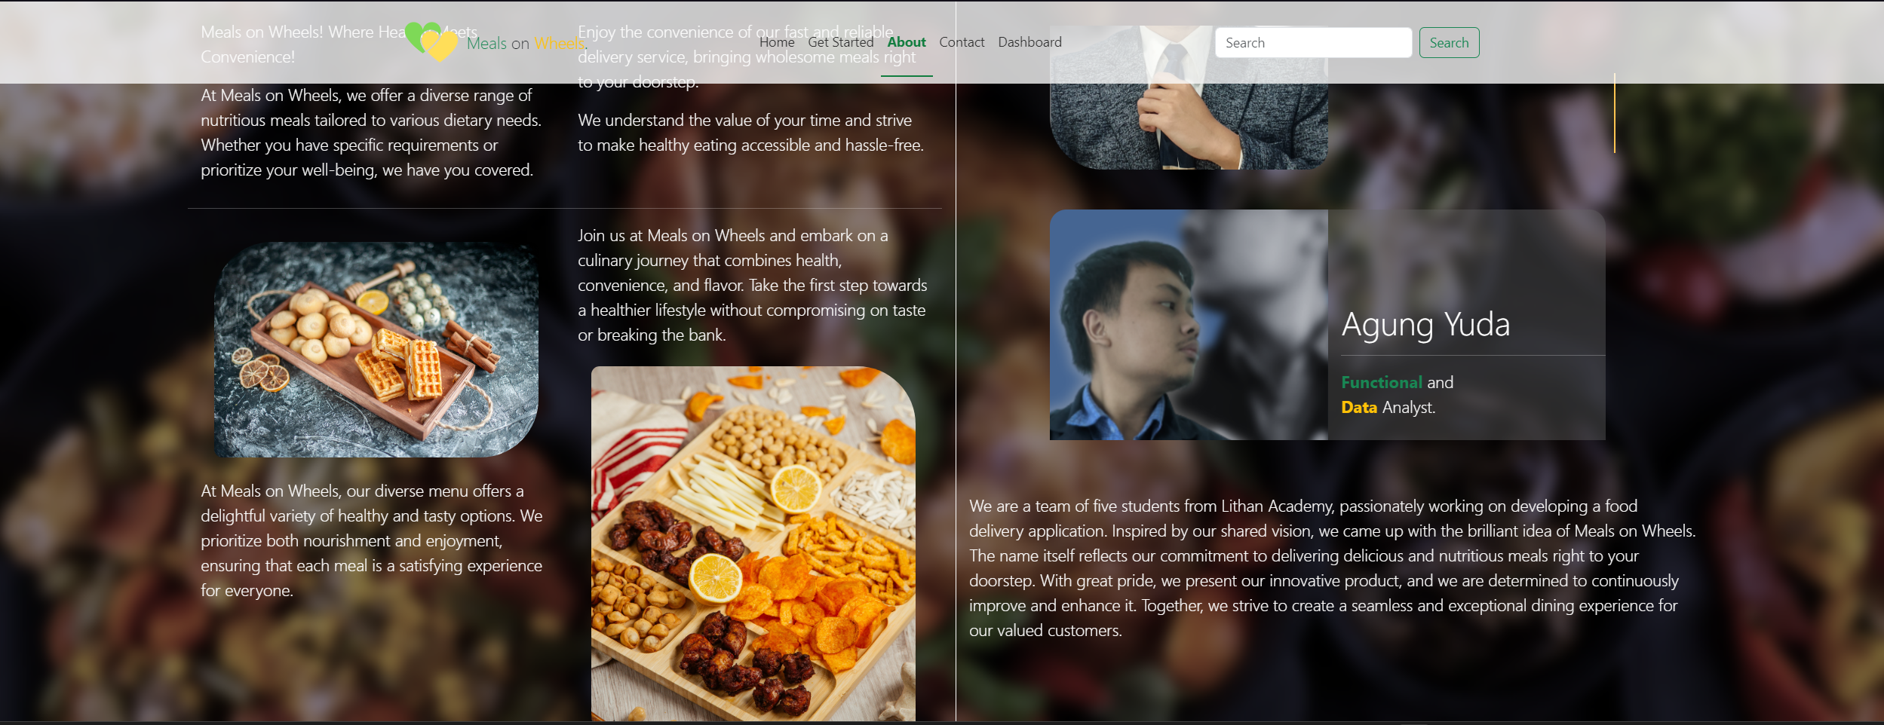
5. Contact Us Page  
   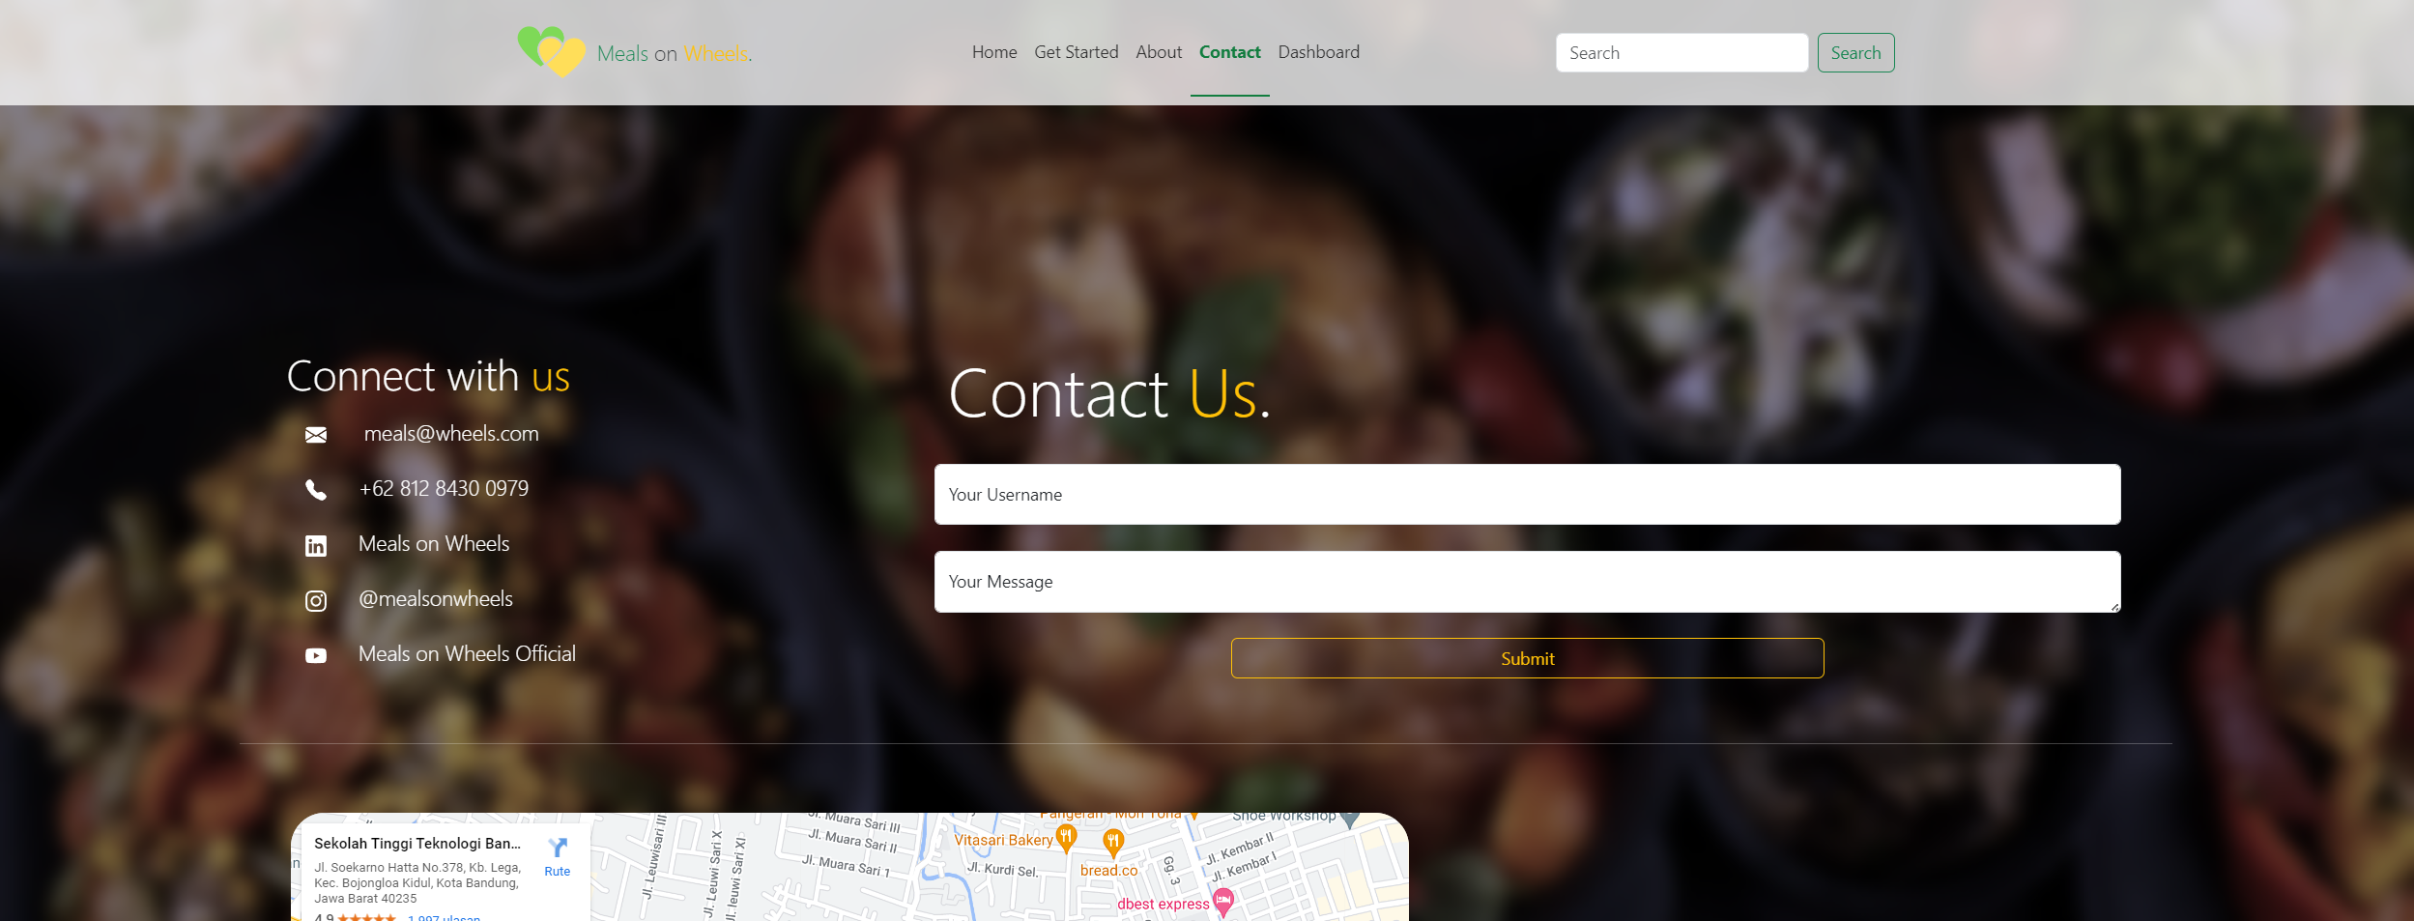  
   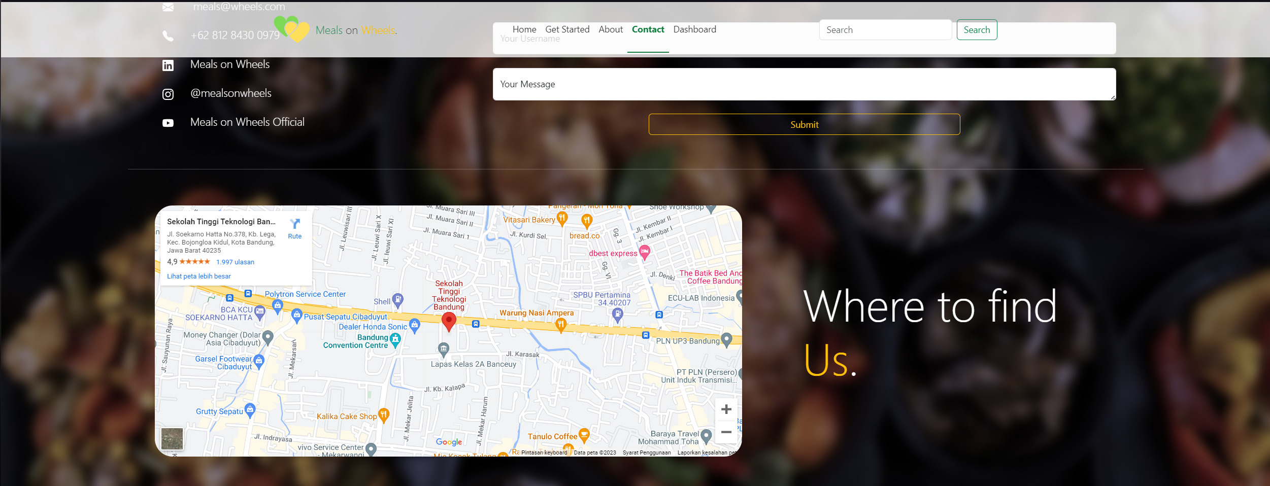
6. Member Dashboard

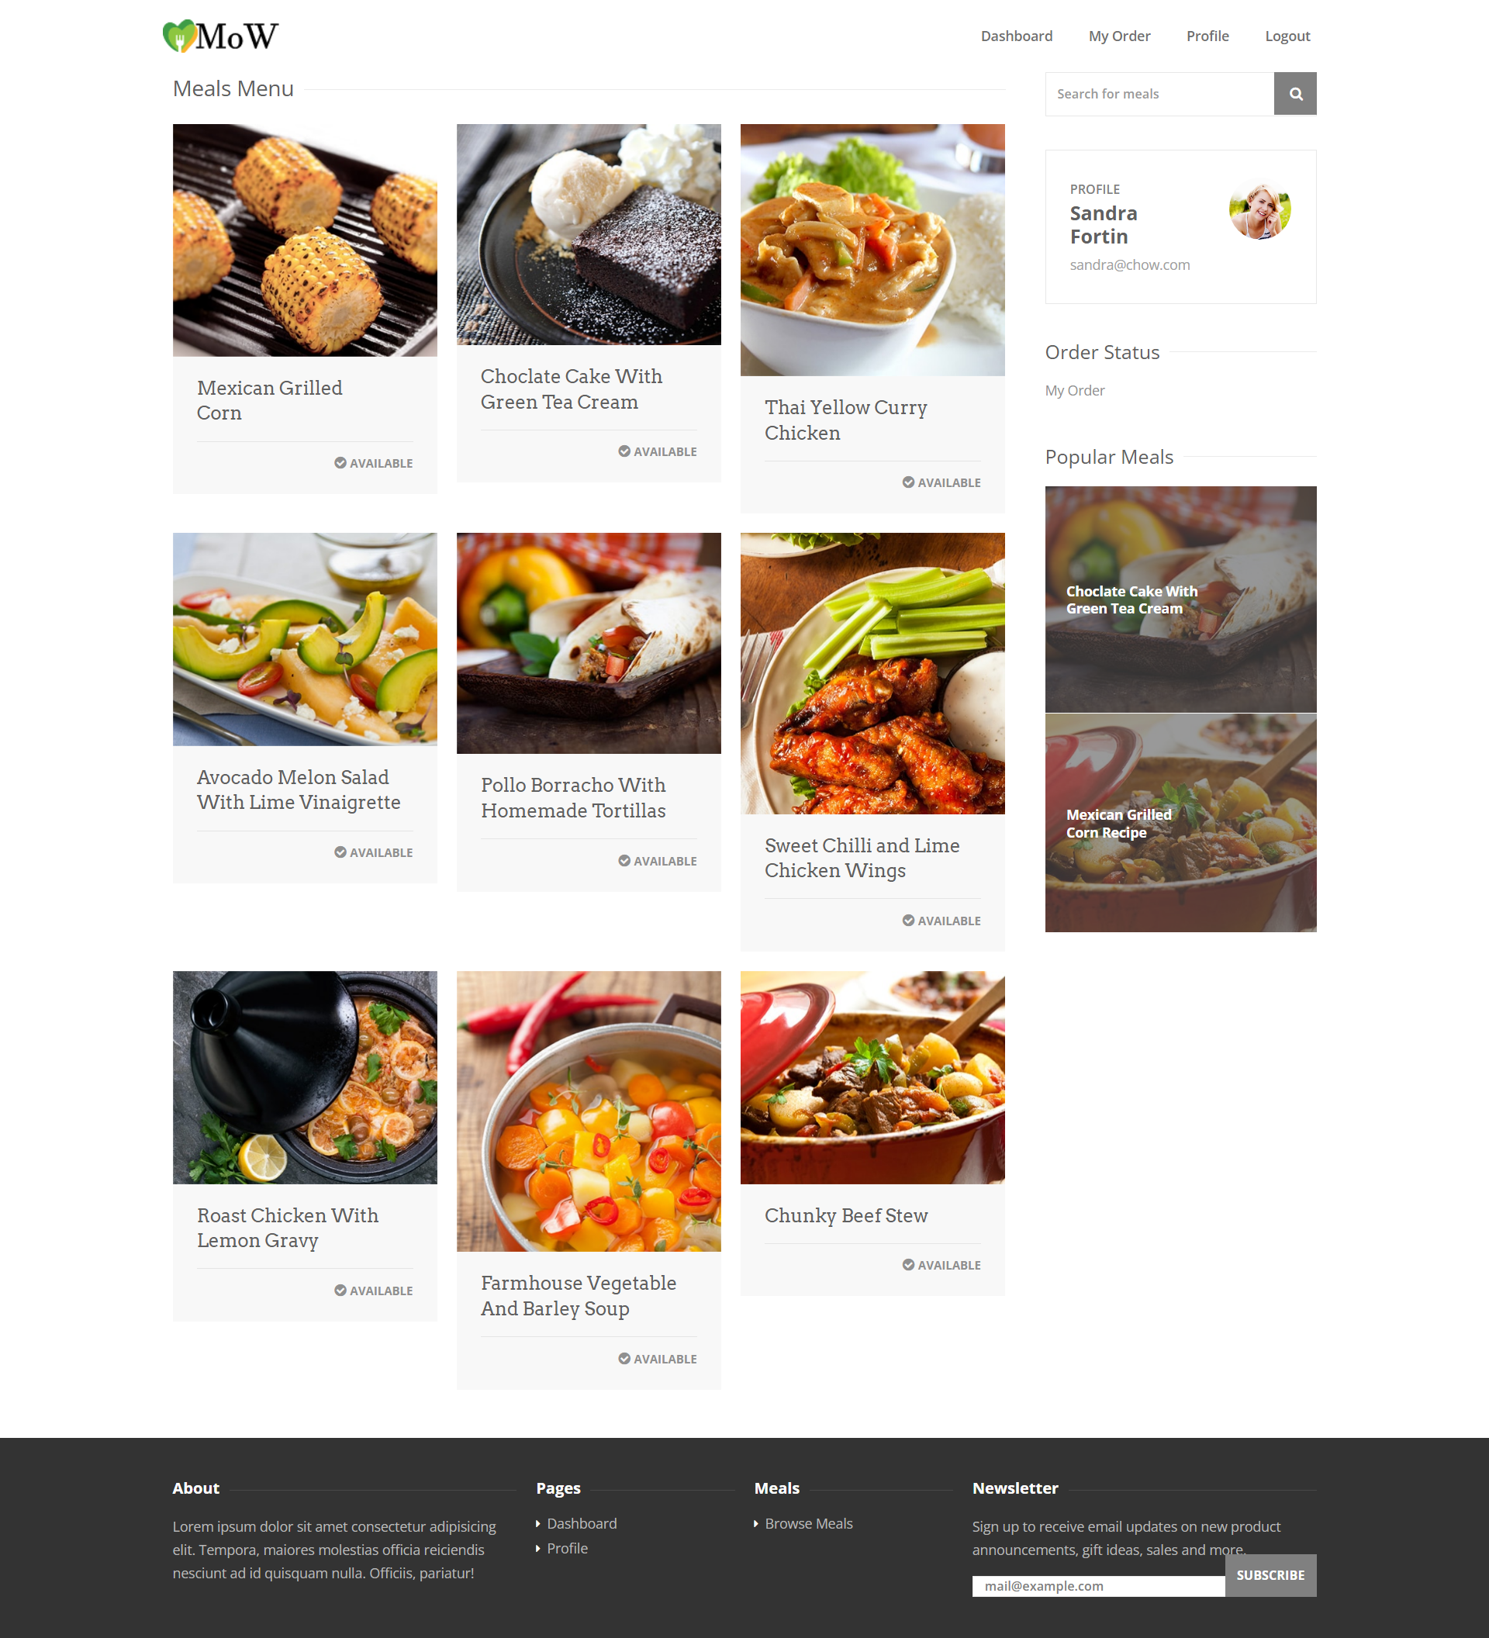

1. Member Meals Details Page

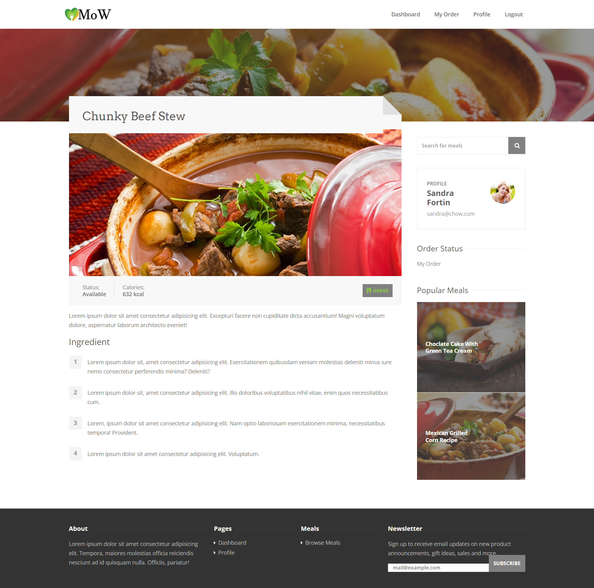

1. Member My Order Page

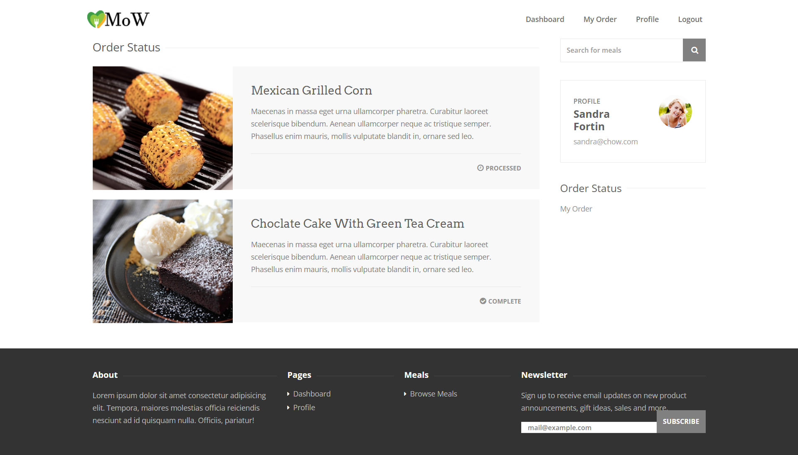

1. Member Profile Page

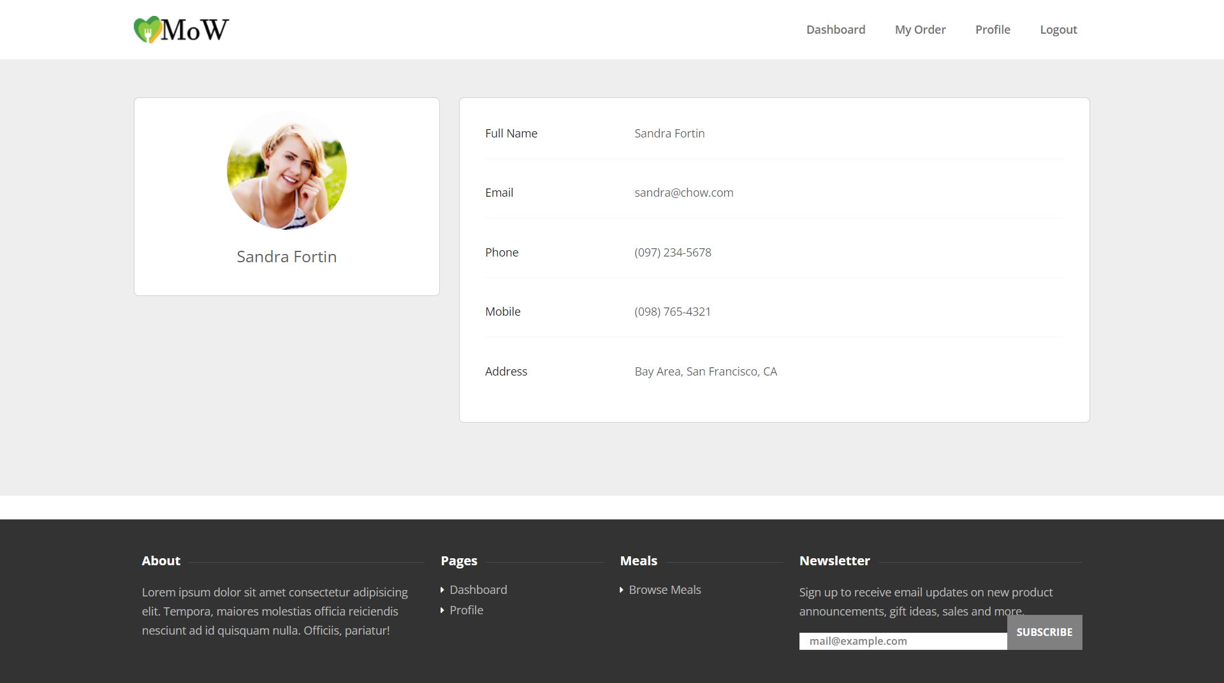

1. Admin dashboard

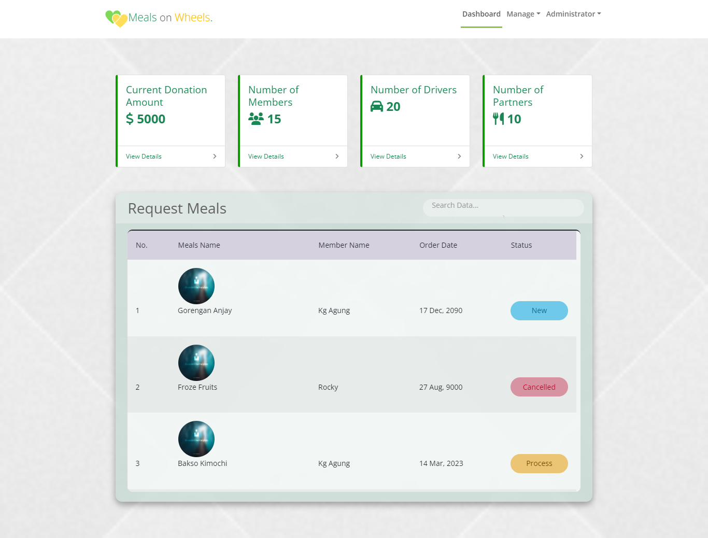

1. Admin Manage Meals

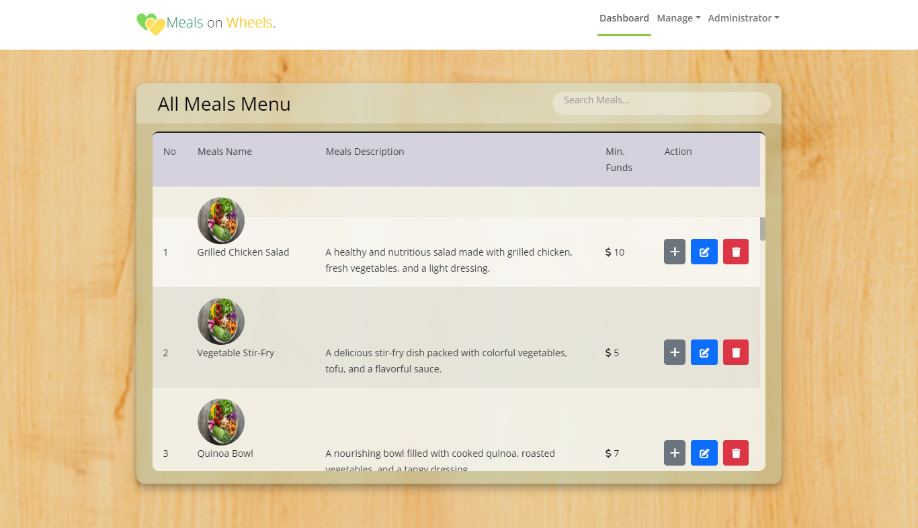

1. Admin Manage Donations

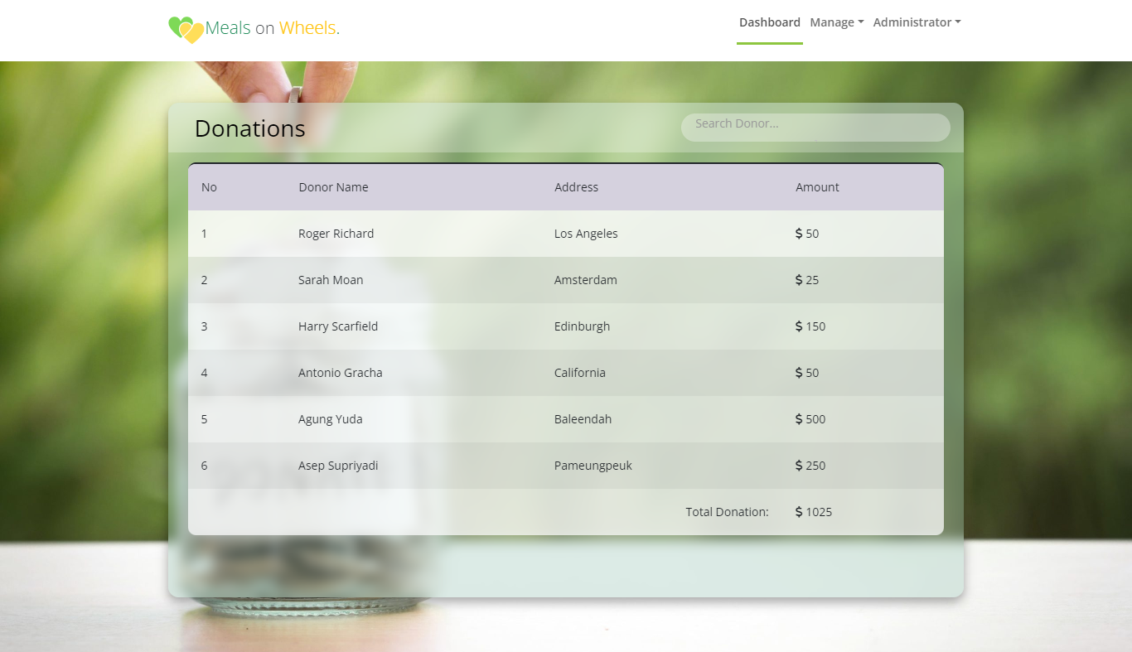

1. Admin Manage Members

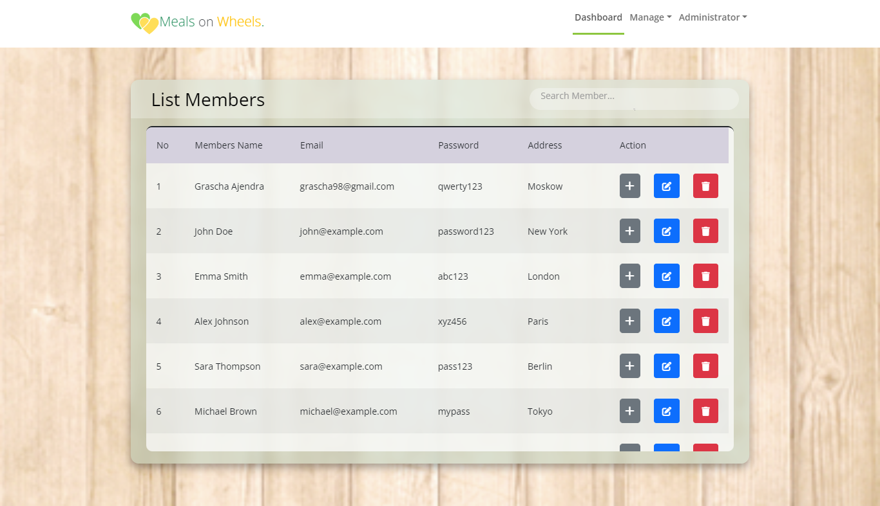

1. Admin Manage Order

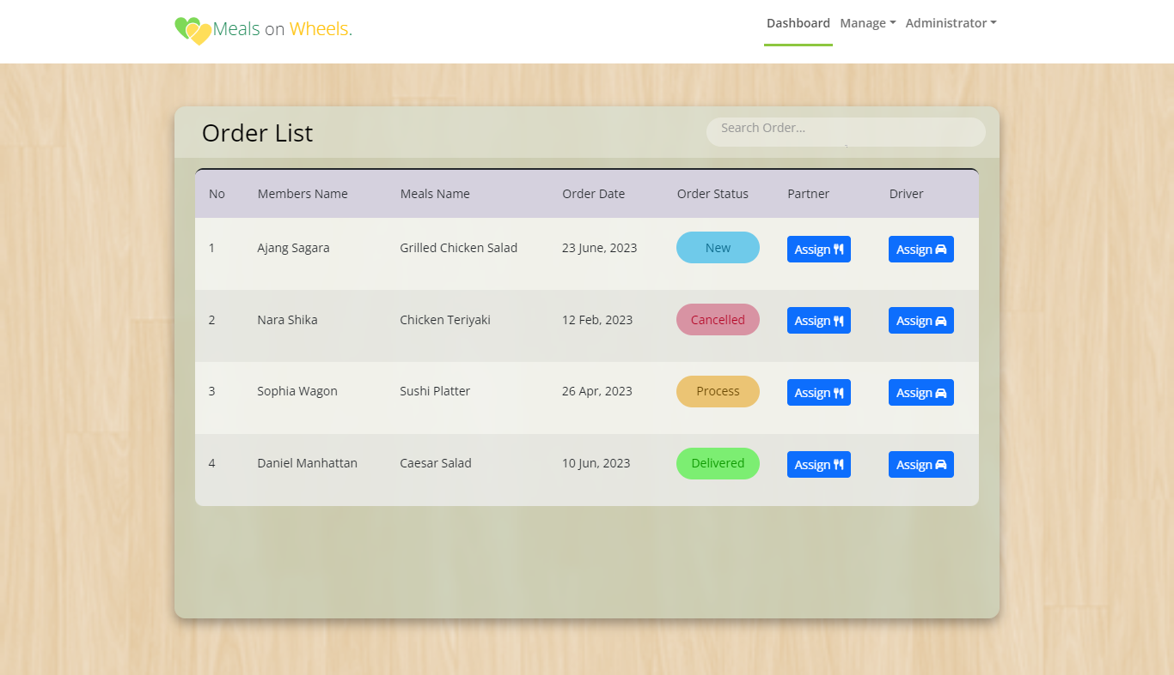

1. Donor Dashboard

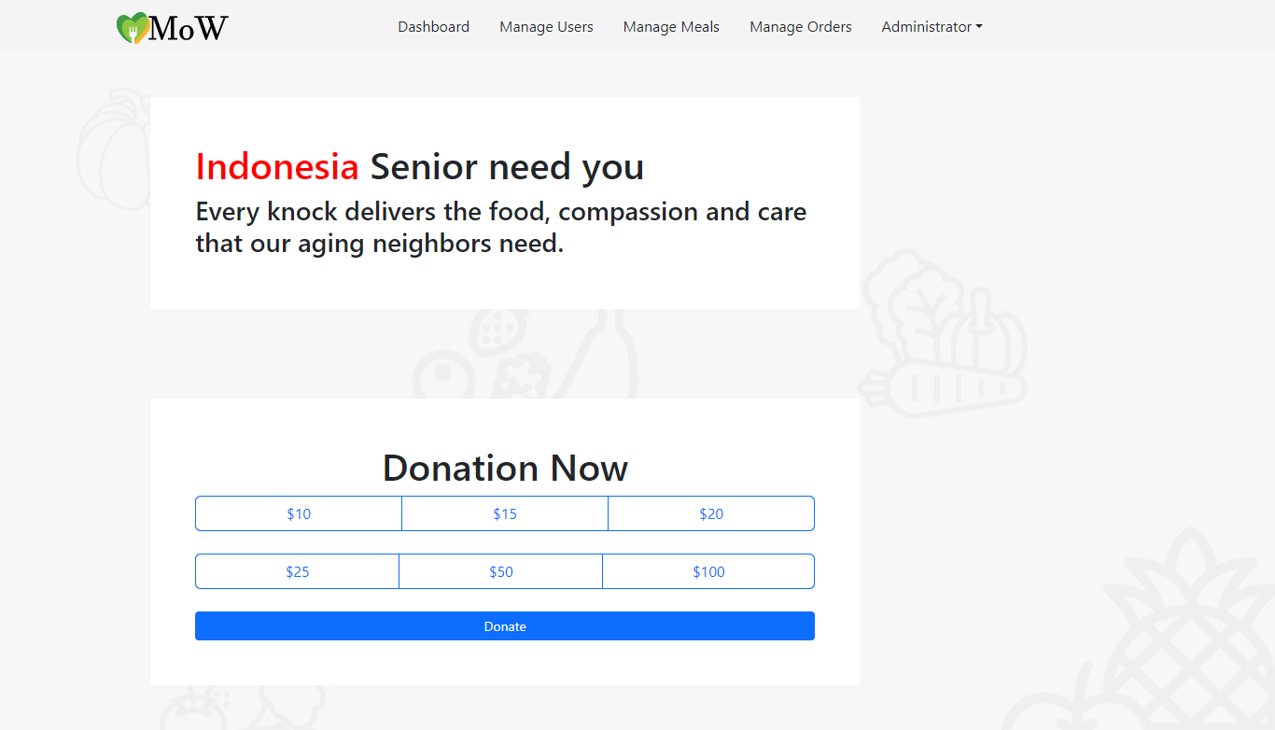

1. Partners dashboard

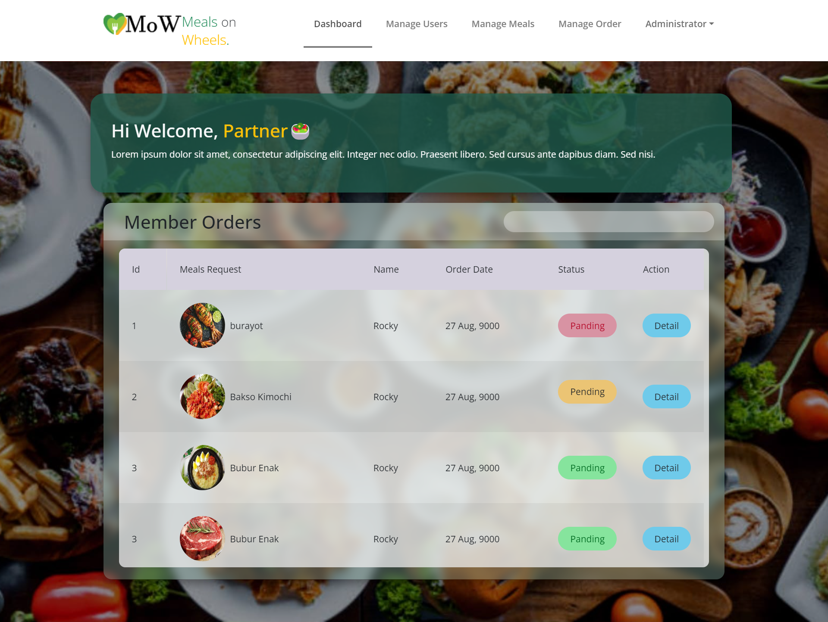

1. Caregivers Dashboard  
   